ARTH 342 Early MEDIEVAL ART

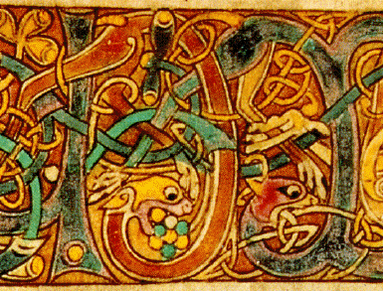

T/R 9:30-10:45 Rutledge 127
Dr. Laura Rinaldi Dufresne x 2661 dufresnel@winthrop.edu
102 McLaurin - Office Hours M/W 1-2pm
Website: http://faculty.winthrop.edu/dufresnel

Required Text: James Snyder Medieval Art, latest paperback edition
& articles listed on course schedule
Recommended Text: James Hall’s Dictionary of Subjects & Symbols in Art, latest ed.

Course Description: Study of the art and architecture of the Early Medieval Period from Late Antique, Early Christian, Byzantine, Celtic and Tribal European arts, Islam, Carolingian and Ottonian Art up to the year 1000 CE.

The term “The Early Middle Ages” refers to the 1000 years between Christs’s birth and the end of the Ottonian Empire. One might argue that the Roman Empire continues to exist, in the Eastern centered, Greek speaking realm now called the Byzantine Empire. Early Medieval art was difficult for scholars of classicism to appreciate or comprehend and was derided for its lack of uniformity, standards and rules (although admired today for these very reasons). The so called Dark ages became the setting for the modern “fantasy” genre in our novels, movies, and video games -precisely because it is the source of nearly all European legends from Arthur, Isolde, and Beowulf to Elves, Fairies and Giants. The Early Middle Ages also marks the birth and spread of Christianity and Islam. All this, and more, is reflected in the art of the Early Middle Ages which we will explore through readings, lectures, films, discussion, writing, examinations and art projects.
GNED: ARTH 341 fulfills GNED requirements for Historical Perspective, and Humanities and the Arts. Goal 1.1 Read, write and speak standard English is met through writing assignments & essay exam questions, Goal 1.3 Understand and practice rhetorical techniques and styles by writing and giving oral presentations is met by the power point presentation of research, Goal 3.2 Analyze and use a variety of information gathering techniques is met through the research paper assignment, Goal 4. 1 Analyze diverse world cultures, societies, languages, historical periods, and artistic expressions and Goal 6.1 To understand aesthetic values, the creative process, and the interconnectedness of the literary, visual, and performing arts throughout the history of civilization are met through reading, lecture, research and exams on course description content.
Expected Student Learning Outcomes: Upon completion of the course, students should be able to identify major artists and work from the period and discuss them within their specific historical and cultural contexts in satisfactory written and oral formats, and display competent citation skills on a research paper.

Course Requirements & Grading: 100 points total

Research Presentation 15
Exams (2 @ 25 points each) 50
Paper/Project/Presentation 30
(5 or 10 project, 5 presentation, 20 or 15 research paper)
Attendance/Participation 5
Grading Scale:
94-100% = A; 90-93 = A-; 87-89 = B+; 84-86 = B; 80-83 = B-; 77-79 = C+; 74-76 = C; 70-73 = C-; 67-69 = D+; 64-66 = D; 60-63 = D-; 59 or less = F

Classroom Rules:
- Take notes! On everything –lectures, readings, films…
- Participation is part of your grade, so speak up!
- more than 3 absences,tardinees or sleeping in class results in grade reduction
- no electronic gadgets (cell, ipods, computers etc). in class
- No late work accepted without doctor’s excuse, etc.
- If you require special accommodations contact Gina Smith x 323 2233

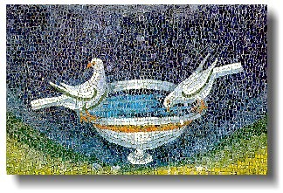

Tues. /Thurs. Class Schedule 2007 (subject to change)

JANUARY readings in Snyder
12 Introduction to the Middle Ages Ch 1
14 Late Antique Ch 2
St. Jerome’s Letter (website)
19 Late Antique Ch 3
Andre Grabar “Early Christian Iconography” in Harold Spencer’s Readings in aqrt History, vol. 2, 3rd edition (see my website or Dacus reserve)
21 Late Antique / Early Byzantine
Boethisus (website)
26 Early Byzantine Ch 4
28 Early Byzantine
FEBRUARY
2 Angles, Saxons Ch 7
4 Celts, Merovingians/Visogoths
6th Rules of St. Benedict
http://www.ccel.org/ccel/benedict/rule2/files/rule2.html#ch1
9 Early Islam Ch 10
11 Islamic Spain p. 234-39
16 Mozarabic p. 239-244
18 presentations
23 presentations Midterm Exam Questions – due 3/4
25 presentations

MARCH
2 Carolingian Ch 8
Libri Carolini (website)
4 Carolingian
Midterm Exam Due today
9 Carolingian
12 Viking Ch 9 214-219
16 Spring Break
18 Spring Break
30 Middle Byzantine Ch 5 pp 91-104

APRIL
1 Middle Byzantine/Ottonian
6 Ottonian Ch 9
The Dulcitius by Hrotswitha 109-117
in Medieval Culture & Society ed. By D. Herlighy
8 Ottonian
“Bernward and Eve at Hildesheim” by Adam S. Cohen and Anne Derbes Gesta, Vol. 40, No. 1 (2001), pp. 19-38 (JSTOR)
13 Italy 7-10th centuries
2nd Exam Questions due2/28
15 Presentations
20 Presentatins
22 Presentations
Papers/Projects Due Today

Final Exam due noon Wed. April 28th

ASSIGNMENTS

- Article Discussions 5 points see dates on calendar
- Read all articles on syllabus & be prepared to discuss
- Turn in notes for both
- General attendance

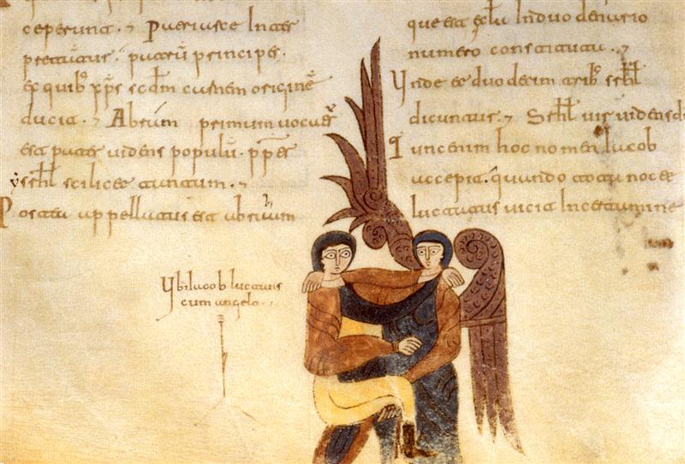

- How to Review an Article -
- Read it at least two times.
- State: Author, Title, and Date of Publication.
- Thesis Statement.
Why was this written? Purpose? Main Point?
State Thesis in One or Two sentences only!
- How is the article structured? Thematic or Chronological subheadings? Etc.
- What is the methodology of the writer? Historical? Marxist? Formal or aesthetic?
Museum Curator? Artist? Collector?
- What are the major points of each section?
Does the author cite many supportive facts or examples, Or focus on just a few? Why?
Include only the best supportive points in your review – not all.
- What is the tone of the article/book? Persuasive? Angry? Scholarly? Detached? Personal? Humorous?
- Who is the intended audience? Students? Professor? Artists?
- What were your favorite parts of the article? Amazing facts, personal stories?
- Was the article successful in proving the thesis? What were the strengths and weaknesses, if any?
- Did you find the article useful? Why or why not?
- Summary: Consolidate your findings as expressed in #3 & 10.
- Keep in Mind -
- In general, the articles I assign are written for other scholars, not students. Therefore they will be difficult. You may critique the writing, but not for being too difficult.
- For any scholarly reading expect to read it twice before attempting to write a review. It will become much clearer the second time around.
- Take Notes during that second reading.
- Paraphrase as often as you can. Avoid long quotes.
- Regarding number 4 – cite all sources properly, even when paraphrasing.
- If presenting your review in class – do not read from a highlighted Xerox of the article! Have note cards or prepared presentation – well organized and ready to read (especially if you are nervous.)

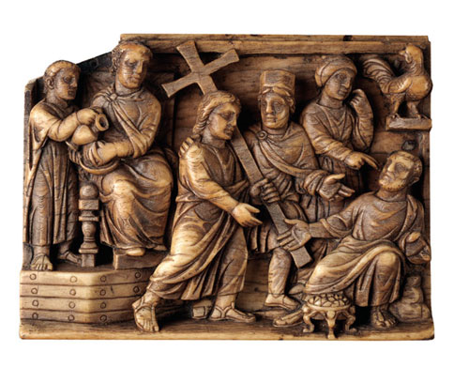

Presentations 15 points Feb 18, 23 & 25th

Choose a work of art* from the early Medieval period dated from 0-1000 CE (preferably not in our text)

Research this work of art with regard to style, meaning and medium,.

Present your discoveries via a 5-7 minute a power point presentation (compatible with our classroom system).

Turn in typed, properly formatted bibliography of at least 4 sources on the day of your presentation.

Do not include Wikipedia in your Bibliography. Go to the original sources they list instead.

*Examples: catacomb, sarcophagi, reliquaries, ivories, mirrors, shrines, belt buckles, manuscript illuminations, jewelry, stone crosses, mosaics, cloisonné, apse decorations, palace decorations, liturgical objects, sculpture and relief carvings, churches, palaces, crowns, rings, book covers

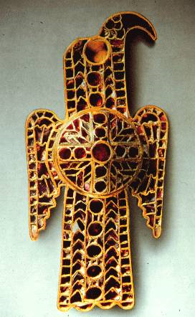

Final Project/Presentation & Paper 30 points December 11th 8-11 am
OPTION 1: EMPHASIS ON ART WORK
Art worK 10 points; paper 15 points; presentation 5
OR
OPTION 2: EMPHASIS ON PAPER
Art work 5; paper 20; presentation 5

5-7 Paper typed, double spaced, bibliography, citation etc
5-7 minute presentation

- Choose an important site (religious or historical) or person (saint or king or warrior or nun etc.), either Pre-Christian (includes Jewish, Celtic, Viking etc. but NOT classical), Christian or Islamic that was in use from the time of Christ up until the year 1000 anywhere in Europe and the Mediterranean region.

- Research the history of that site or person carefully, and explain the story, sacred, historical or legendary event associated with that site or person.

- Design & Make a shrine or memorial or objects for that shrine or memorial (chapel, statue, mosic, relief carving ,reliquary, etc) for the site or person you have researched. If there is already a building at the site (for example, Hagia Sophia) then design an object for that shrine (for example, a liturgical object, a reliquary, a book cover, an illuminated manuscript page, a crown, a metalwork relief, a water pitcher, an apse mosaic, a dome fresco, e a sarcophagus, etc.)
.
- Write a 5-7 page (typed, double spaced, in folder) paper (art option 5-6 pages, paper option 6-7 pages). Document your research of the sacred site, to whom or what it is devoted, and explain the relevance of your design, its purpose and meaning.

- Include a Bibliography of 5 sources not including text. Do not include Wikipedia in your Bibliography. Go to the original sources they list instead.
- Cite sources in text for all ideas as well as quotes properly (I like endnotes & footnotes)
- If you are worried about your artistic abilities, jplease choose option 2, eith the emphasis on the paper. . The design should be as original as possible, but faithful to the art of a particular place and time I so:
- Support your design with relevant images you are using for inspiration that were actually made at that time and place.

NO PAPER WILL BE ACCEPTED WITHOUT:
CITATIONS IN TEXT, BIBLIOGRAPHY, IMAGES, STAPLE OR FOLDER

****

ANNOYING WRITING ERRORS TO AVOID

Titles:
ALWAYS put titles of works of art in on of the following: The Annunciation or The Annunciation or “The Annunciation”

Words to avoid
- Talks or talks about:
Use a thesaurus – use discusses claims, wrote, argues….
- Seems or seems like:
Just strike it out – too passive, be strong!
- Feels or feels like:
Use thesaurus for stronger wording
- Really:
Just avoid it
- Fabulous –
Too over the top – describe it well, and this will not be necessary

Do not start a sentence with:
- And, but, Because

Other errors:
- -No contractions!
- Use do not (not don’t) etc… in a formal paper

Avoid these phrases:
- The author “starts out”---- (begins is a better choice)
- The author “goes on to” -- (explain)
- Do not use the same phrase or word over & over…especially in the same sentence or paragraph boring – use your thesaurus!
- Do not begin paper with birth date & place of the artist ---
Too unimaginative – Find an interesting fact or quote about them or something!!
Ex. Of Early Medieval Art

Mosaic Apse, San Apollinare in Classe, 6th, Ravenna Italy Archangel Michael, Ivory, 6th
Balustrade Relief, inscribed Baptistery, Cividale, Italy Fuller Brooch, Anglo Saxon 9th
Carolingian book cover, Lindau Gospels 870 Baptistery of Florence 1060
Harbaville Triptych, ivory, 10th century Echternach Gospels 690
Sion Treasury Book Covers, 6th, Dumbarton Oaks Muirdach Cross, 900, Ireland
Chalice of Emperor Romanos II, 10th, Venice Frank’s Casket, 8th, London
Witches Pallium, 11th Spain, Islamic Hitda Gospels, 11th Germany

Maria G. Parani

Lighting in Early Byzantium : Dumbarton Oaks, Laskarina Boura, Maria G. Parani (Paperback, 2009)

